Assignment 2

Q1

The code is written in q1.py.

The code includes 1 main function: sqrt(n)

C:\Users\Jeff\Documents\WeChat Files\wxid_ct31glzzaxml22\FileStorage\Temp\1668704118577.pngThe code will print the approximate square root of 5 and 37 (as it had been set) with slightly error less than 0.0001 as follows if it is run.

Q2

The code is written in q2.py

The code includes 1 main function: emirp\_100() and some included function: reverse(n), isPalindromic(n), isPrimeNumber(n), isEmirp(n) and main3().

The code will print 100 emirps in lines within 10 emirps in each line as follows if it is run.

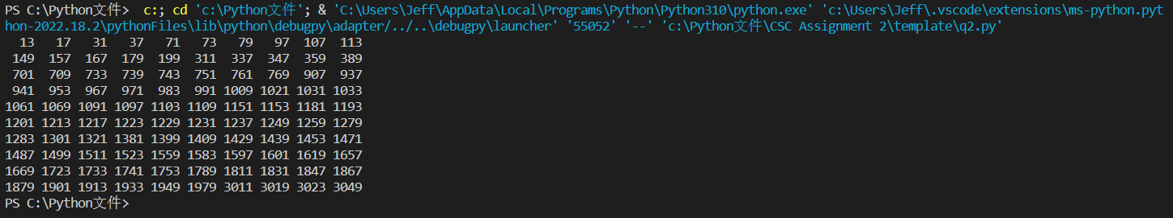

Q3

The code is written in q3.py.

The code includes 4 main functions: isValid(password), sumOfOddPlace(password), sumOfDoubleEvenPlace(password) and getDigit(x)

The code will print out whether the password inputted is Valid or not according to the Rule (It will directly print out ‘4388576018402626 is InValid 4388576018410707 is Valid’ as follows as the two numbers were set).

(Out of requirement in “if \_\_name\_\_==’\_\_main\_\_’”) But if give the isValid(password) function a password that is not of the required length, it will print ‘The number is incorrect.’ or a password that doesn’t starts with 4,5,37 or 6, it will print 'The password is incorrect. There is no such bank.'.

Q4

The code is written in q4.py

The code includes 1 main function: isAnagram(s1,s2)

The code will print ‘True’ or ‘False’ if two strings (s1 and s2) are anagrams of each other or not if it is run. (As set in template, it will print ‘True’ ‘False’ ‘True’ ‘False’ ‘True’ as follows)

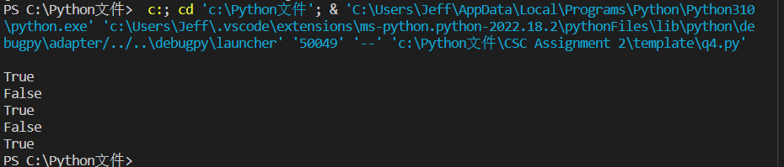

Q5

The code is written in q5.py

The code includes 1 main function: locker\_puzzle()

The code will print a list including the number of lockers which are open in the end as follows if it is run.

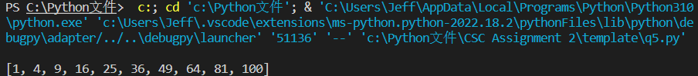

Q6

The code is written in q6.py

The code includes 1 main function: eight\_Queens()

It will randomly print one of the solutions of eight queens problem in the form like a chessboard as follows if it is run.

